# **December is for Professional Development**

### Skill development resources for early career professionals

Zoe's avatar

[Zoe](https://substack.com/@zoeffc)

Dec 06, 2024

Share

Happy December!

We made it to the last month of the year!

December is a good month in the corporate world. It is a month for slowing down and finally getting to those projects that you’ve been meaning to get to all year. I am willing to bet that a decent chunk of your team is out for at least 3 weeks of this month, so your email is going to slow down. Plus, it is widely accepted that December is the Friday of the year. So, what will you do with your breathing room? Maybe we can do a little bit of brainstorming on Discord. However, I have one suggestion: professional development.



*Art by @marikadoodles⁠ ✨*

First some housekeeping:

📫 If a friend forwarded you this newsletter (then you have some really cool friends), and you may want to consider joining us here for regular updates.

[Subscribe](https://femme-futures.beehiiv.com/subscribe)

🧲 Got some thoughts you want to share? Join us on Discord to chat all things newsletter and corporate life.

[Discord](https://discord.gg/N84WxemQ?utm_source=femme-futures.beehiiv.com&utm_medium=referral&utm_campaign=december-is-for-professional-development)

You can find all archived newsletters at the online site, if you ever want to go back or if you just feel like perusing.

[Check out the website](https://femme-futures.beehiiv.com/)

In the quiet times, I find myself getting anxious because twiddling my thumbs doesn’t feel aligned with my capitalist conditioning. Fortunately, working on myself *is* aligned with my capitalist conditioning. Engaging in professional development is a way to do something interesting and productive that isn’t busy work or constantly refreshing my inbox looking for new tasks to take on.

Here are 10 ideas for professional development activities that you could do to get through the Friday of the year:

1. **Learn a new software/technology.** This is your moment to master Excel. May the force be with you. [Alternatively, learn canva or photoshop or any other number of platforms that have been on your radar screen in the last year.]
2. **Learn how to more effectively use AI.** I wrote about this in [*a newsletter*](https://femme-futures.beehiiv.com/p/lets-talk-ai) from July, but the TLDR; is that AI is already a widely used tool and as people who intend to be in the workforce for the next 30-50 years, we need to get comfy using it. Find out if your organization has invested in any of the AI platforms, if they have, play with that one — if they haven’t, play with the free ones.
3. **Figure out what professional development resources your organization has and pick a couple to try.** If you work for a bigger organization, you likely have a ton of professional development resources available to you. However, even smaller organizations tend to have resources available for professional development (and often a budget to invest in your growth!).
4. **Look into professional development courses through organizations in your field.** Professional networks are resources! In my field, this is an organization like [*CASE*](https://www.case.org/?utm_source=femme-futures.beehiiv.com&utm_medium=referral&utm_campaign=december-is-for-professional-development). Find whatever exists in your field and see if you can take advantage of it!
5. **Learn a new skill.** Would your work be improved if you knew basic coding? What if you upped your graphic design game?
6. **Read a book.** There are a ton of professional development books out there. I recommended a couple in [*this newsletter*](https://femme-futures.beehiiv.com/p/resting-reading) from August, but since then, my list has grown. I am considering launching a Femme Futures Book Club in the new year, so stay tuned!
7. **Take a personality test (or two).** There are a fair number of corporate-focused personality tests that give you an interesting insight into your work style. I muse on them in [*this newsletter*](https://femme-futures.beehiiv.com/p/personality-testing) from October. Check out MBTI and Enneagram tests.
8. **Make some work resolutions.** ‘Tis the season to dream about the person that you will be next year.
9. **Work on a project that includes skills that you want to improve upon.** That’s what Femme Futures is for me, and the bonus is that you get a product to reflect on at the end.
10. **Network**. Scroll through LinkedIn. Scroll through your organization’s Team page. Make friends. [*Here*](https://femme-futures.beehiiv.com/p/talk-networks) are some more thoughts in a newsletter from June.

Good luck!

Zoe

P.S. It’s the six-month anniversary of the Femme Futures Cooperative!

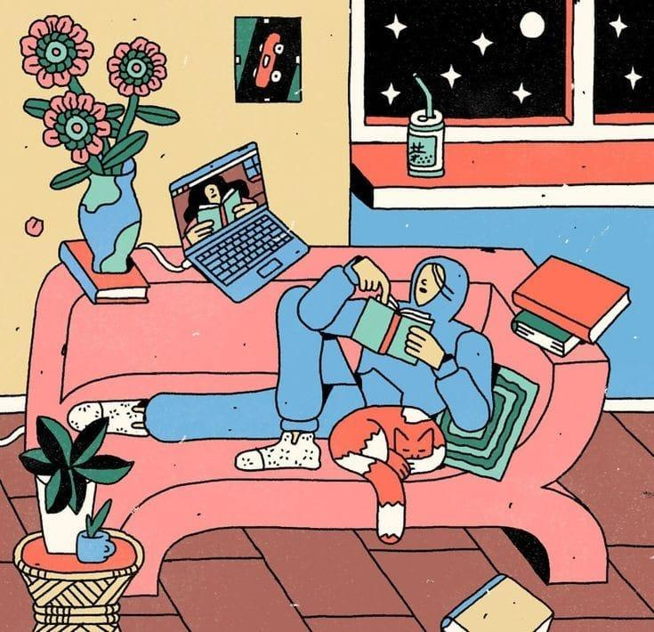

*artist unknown*

**Femme Futures Cooperative Founding Principles**

💚 **Mission**: The mission of Femme Futures is to create a community space for young professionals who identify as over-achievers and activists to generate collective success by providing resources and platforms to thrive in challenging workplace environments.

💙 **Vision**: To contribute to a world where driven individuals are equipped with the tools, guidance, and connections to overcome systemic barriers, fully utilize their talents, and enact positive change in their organizations and communities.